|  |
| --- |
| **JDN Standards – Deployment Guidelines** |

Introduction 1

Guidelines 1

Core components 2

Firewalls 2

Switches 2

Virtualization platform 3

Backup storage 3

UPS 4

Time server 4

Core component cheat sheet 5

Additional components 5

Rack mounting 5

Networking 6

Small mobile setup 6

Clients 6

“Offshore” vessels 7

# Introduction

This document provides guidelines for deployment of new equipment within the JDN Standards for Sites & Vessels as defined in 2015.

This document aims to offer guidance in selecting the right equipment for deployment to sites (remote offices, workshops, etc.) and vessels (main and auxiliary floating equipment, etc.) in the Jan De Nul. In case of doubt, contact the SA/SE & TSE team leads for clarification.

# Guidelines

We distinguish between four different setups, referred to as "large", "medium", "small R430" and “small DL20”:

* Large is a setup representative for a large vessel or large remote office.
* Medium is a setup representative for a smaller medium sized vessel or a small remote office.
* Small R430 is a setup representative for our small vessels (while still having servers on board) with more than two PC’s, a small remote office or a temporary workshop.
* Small DL20 is a setup representative for our small vessels with maximum two PC’s

The choice between large & medium setups for vessels is dependent on the connectivity available on the vessel. If VSAT is available, the large setup should be used.

A small R430 setup should only be used on vessels if there is absolutely no room available for a large or medium setup. It should only be used if there is no way to install a proper deep rack to house the large or medium setups on the vessel.

A small DL20 setup should only be used on vessels with maximum 5 PC’s, 5 virtual client machines and if there is no way to install a proper deep rack to house the small R430 setup on the vessel.

The choice between the available setups for sites (remote offices, workshops, etc.) is dependent on how critical the services or data stored on the system is, or how large the user base is. Note that the user base is not necessarily only the local users, but also the remote users. Consult the table below for the choice matrix for **site deployments**:

|  |  |  |  |  |  |  |  |
| --- | --- | --- | --- | --- | --- | --- | --- |
| **#Users** | **Critical** | | **Time frame** | | **Minimal setup type** | | **Payment** |
| Any | Any | | Start up | | Small | | Rental or Purchase |
| <15 | No | | <3y | | Small | | Rental or Purchase |
| <15 | No | | ≥3y | | Small | | Purchase |
| <15 | Yes | | <3y | | Medium | | Rental or Purchase |
| <15 | Yes | | ≥3y | | Medium | | Purchase |
| 15-29 | No | | <3y | | Medium | | Rental or Purchase |
| 15-29 | No | | ≥3y | | Medium | | Purchase |
| 15-29 | Yes | | <3y | | Large | | Rental or Purchase |
| 15-29 | Yes | | ≥3y | | Large | | Purchase |
| ≥30 | Yes or No | | <3y | | Large | | Rental or Purchase |
| ≥30 | Yes or No | | ≥3y | | Large | | Purchase |
|  |  |  | |  | |  | |

Note that “start-up” deployments are by definition meant to be limited in run time. They should be quickly replaced with an appropriately sized setup.

# Core components

## Firewalls

Three types of firewalls are available within the defined standards: Fortinet FG-80E, Fortinet FG-100E and Fortinet FG-300E.

Large deployments will have a redundant FG-100E, or a FG-300E when URL filtering is important, in the last option system engineers will be consulted first.

Medium & small deployments on board of vessels will always have a redundant FG-100E.

Medium & small deployments on land (sites, offices, workshops, ...) will always have a standalone FG-100E.

Small setup boxes will always have a FG-80E.

## Switches

Four types of switches are available within the defined standards: Juniper EX3300-48T, EX3300-48P, EX3300-24T, EX2200-48T & EX2200-C-12T.

Large & medium deployments will primarily make use of the EX3300-48T and exceptionally of the EX3300-24T. The small EX2200-C-12T switches are a stopgap measure which can be used in rooms where there are not enough patchings available, but where a larger switch would be overkill.

Small & medium setups can utilize all four distinct switch types. However, the EX2200-48T switches are exclusively meant for deployment in offices or workshops where the IT setup is present in the same room as the office workers and where noise complaints are to be expected. In all other locations the EX3300 series switches should be used. This means that an small or medium setup on board of vessels or floating equipment should never use EX2200-48T switches, even if noise complaints are to be expected.

EX3300-48P switches are only used to power wifi access points through PoE+, in setups where no power adaptors can be used to provide power. These switches are never used as the two first switches of a stack, and are added to the two first EX3300-48T used to connect the IT hardware.

Generally, two EX3300-48P will be issued to ships with HP W-IAP access points. For sites, PoE+ switches are generally only used as a last resort, and using adapters are preferred as a cost saving measure.

For all vessel setups, one spare (non-PoE) switch will be shipped and kept in storage to replace a failed switch.

## Virtualization platform

Three types of virtualization platforms are the Dell VRTX chassis with M630 blades, the Dell R430 and the HP DL20.

Large deployments always utilize the Dell VRTX with 3 blade servers, while the medium deployments use the Dell VRTX with only 2 blade servers. The standard amount of disks in the VRTX is 16 600GB disks (14 disks in a RAID6 array with 2 additional hot spares), however for large offshore vessels, a full 25 disks can be preinstalled (2x 12 disks in RAID6 arrays and one hot spare).

Small deployments use the Dell R430 with 8 1.2TB disks installed.

Small vessels with maximum two PC’s use the HP DL20 setup.

## Backup storage

Two main types of NASes are available within the defined standards: Synology RS815+ (rack) & DS1515+ (desktop).

Large, medium & small R430 deployments will always have a redundant (mirrored) NASes, preferably rackmountable ones. Where possible, use the latest revision in stock.

Small DL20 deployments will have a single NAS.

## UPS

Four main types of UPSes are available within the defined standards: APC 6kVA, 3kVA, 2.2kVA & 1.5kVA.

Large & medium deployments will primarily make use of the 6kVA variant, but can optionally make use of the 3kVA in a second location (ECR?). The second UPS is especially useful on board of vessels with a redundant NetApp NAS (Offshore).

Small deployments can use whichever UPS best fits the situation. Small setups sent by airfreight will most likely not contain any UPS at all.

Note that in locations where it is hard to ship heavy equipment to, locally purchased UPSes can be used instead. Where this is the case, please try to use APC equipment that is compatible with APC Powerchute Network Shutdown.

## Time server

A Meinberg LANTime M300/GLN-SQ/LNE with GPS/Glonass antenna can be provided for use on vessels.

# Core component cheat sheet

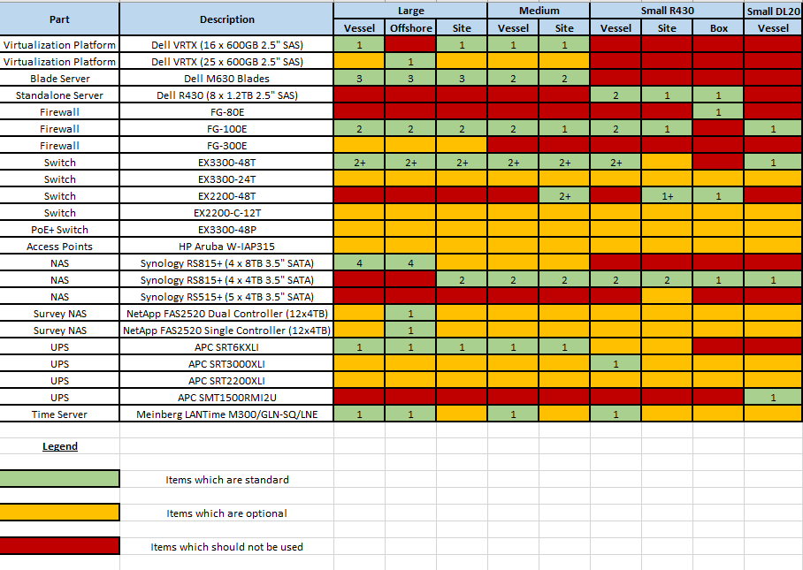

# Additional components

## Rack mounting

Generally, our equipment will be mounted into full sized racks. To be able to mount the large/medium setups, you will need:

* Post-to-post depth: At least 69 cm to accommodate the rack mounting kits. 70 cm should be standard.
* Front clearance: At least 5 cm for VRTX front, as well as enough room for network cables and fiber patchings if relevant to your situation.
* Rear clearance: At least 6cm for VRTX rackmount (can be chopped off to 3-4 cm if really required), as well as enough room for the routing of the UPS hardwire feed (clearance needed will depend on type of cable used, how the cable is fed,...).

The small R430 setups are designed to fit inside a rack with a post-to-post depth of 61 cm when used with R430 “static” rack rails. Specifications:

* Post-to-post depth: At least 61 cm to accommodate the rack mounting kits.
* Front clearance: At least 5 cm for network cables.
* Rear clearance: At least 8cm for the R430 rackmount. The R430 static rail rack mount kit needs to be modified to remove the “single post” mounting option, as it interferes with the rack case.

R430 sliding rails are available for mounting in normal depth racks (69+ cm post-to-post).

The small DL20 setups are designed to fit inside a rack with a depth of 50cm.

## Networking

Switches are stacked using DAC (direct attached copper twinax cables 10 gigabit SFP+) over short distances (same room, usually same rack), and fiber (1 gigabit SX SFP) or copper (1 gigabit Base-T SFP) over longer distances (same vessel or site). When stacking in the same rack, DAC cables should always be used. The exception to this is the EX2200 series switches since does not support 10Gb SFP+, they use 1Gb (fiber or copper) instead. For stacking over longer distances, fiber is always preferred. The Base-T SFPs should only be used if no fiber can be made available.

It is important to note which fiber patch panels are used, since the fiber patch cables needed will vary between ships. All cables are responsibility of TSE to purchase & keep in stock.

HP Aruba W-IAP315 can be supplied to provide Wifi for crew (castle only), AMOS handscanners (rear/below deck at a few of the largest stores), offices and sites. These access points can be powered by adaptors or PoE+. If PoE+ is used, then at least two Juniper EX3300-48P switches will be required. Please keep in mind that PoE+ cannot be fed across long distances and requires higher quality cables as well as properly hooked up patch panels.

## TD Automatization NAS

On suitable vessels (offshore, large, medium and a minority of the small vessels) TD Automatization will require a NAS setup for their backups. This setup will be connected to both the admin_trust & machine networks and is composed of 2 rackmountable units with mirroring set up between both. The exact setup is described in another manual.

## Small mobile setup

The small setup for sites on land (small remote offices, workshop, etc) can be shipped by airfreight in a transit case with integrated 19” rack. These racks are Amazon Racks made by CPCases. This can also include a 3G/4G modem.

## Clients

For testing purposes, TD has approved the following deployment:

* All stores will be issued Dell WYSE 5212/5040 AIO thin clients.
* The Elec workshop will be issued a HP ProDesk 600 G3 SFF desktop with a DVD-RW drive. The Elec will also be issued a laptop.
* All other locations requiring a computer will be issued HP ProDesk 600 G3 SFF desktops with DVD-RW drives.
* If HP ProDesk 600 G2 SFF are not available, HP EliteDesk 800 G3 SFF desktops can be used if approved by your team lead.

## “Offshore” vessels

Large “Offshore” vessels will also be provided with:

* a redundant NetApp solution for Survey use
* a Moxa NPort 5610 serial server
* larger Synology backup storage

The NetApp will be redundant using 2 shelves with a total of 3 controllers. The primary shelf will be installed in the same location as the VRTX and the second shelf will be installed elsewhere on the ship.

Offshore vessels will also be supplied with a Moxa Nport 5610 16-port serial server, as long as the current stock lasts. Once this stock has been depleted, no new serial servers will be ordered.

The standard Synology 4TB disks will be replaced with 8TB to make sure sufficient storage is available for backups.